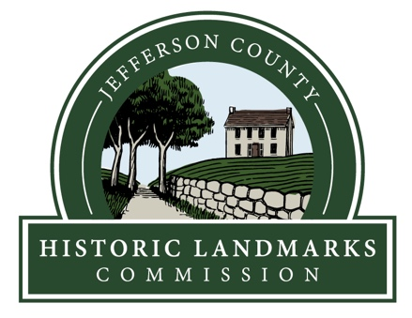
Meeting Minutes
Jefferson County Historic Landmarks Commission
December 11, 2019
Jefferson County Commission Meeting Room

Members Present: Martin Burke (Chair), H.S. Leigh Koonce (Secretary), Carmen Creamer.

Guests Present: McKenzie Hitchcock, John Demer

Mr. Burke called the meeting to order at 7:02 pm.

Public Comment: No public comment was heard.

Minutes of the October Meeting: Mr. Koonce presented the minutes of the October meeting. Mrs. Creamer moved to approve the minutes as presented. Mr. Burke seconded the motion which passed unanimously.

Minutes of November 14th Special Meeting: Mr. Koonce presented the minutes of the November 14th special meeting. Mr. Burke moved to approve the minutes as presented. Mr. Koonce seconded the motion which passed 2-1 with Mrs. Creamer voting no.

Treasurer’s Report: In the absence of the Treasurer, Mr. Burke, stated the bank account balance was $15,613.00. All bills are up to date.

Snow Hill/Poor Farm: Mr. Burke presented the necessary documents to transfer ownership of Snow Hill/Poor Farm to the Rock Spring Church. Mrs. Creamer moved to approve all documents as presented. Mr. Burke seconded the motion which passed unanimously. Mrs. Creamer moved to authorize Mr. Koonce to sign a resolution empowering Mr. Burke to sign all necessary documents on behalf of the Commission. Mr. Koonce seconded the motion which passed unanimously.

Roundtable: Mr. Burke and Doug Perks have discussed the possibility of having a roundtable discussion including the Jefferson County Museum, the Black Historical Preservation Association, Historic Shepherdstown, the Jefferson County Historical Society, and other groups. Ms. Hitchcock will coordinate with other groups and report back interest.

Renewing the MOU with Shepherd University: No action was taken.

Recruiting new JCHLC Commissioners: No action was taken.

Court House Committee: Mrs. Creamer stated no further meetings had been held at this point.

Status of National Register Nominations: Mr. Demer is continuing to work on the nomination forms before him.

AmeriCorps Member Report: A draft of the Washington Homes brochure has been created. Final approval is pending. Posting on Facebook is occurring twice a week and number of views is increasing. Ms. Hitchcock is also working on the West Virginia Property Inventory Forms.

Duffield’s Depot: A Home Depot grant has been submitted for repairs to the steps.

Coyle Cemetery: The repairs to the wall have been completed.

WV GeoExplorer: Tori Myers is working on getting the system back up and running.

Shepherdstown Battlefield: Mr. Burke has been in touch with the American Battlefield Trust about new development plans for Faraway Farms. ABT will update their appraisal and contact Mr. Boltz about possible sale.

At 8:40 pm Mrs. Creamer announced her resignation from the Commission effective immediately. The meeting adjourned due to lack of a quorum.

Respectfully submitted,

/s/
H.S. Leigh Koonce, Secretary
Jefferson County Historic Landmarks Commission

